

**Tribhuvan University**

**Institute of Science and Technology**

**A Final Year Internship Report**

**On**

**‘WEB DEVELOPMENT’**

**At**

**Vacker360 Pvt. Ltd.**

**Submitted to:**

**Department of Computer Science and Information Technology**

**Ambition College**

**Mid-Baneshwor, Kathmandu, Nepal**

**In partial fulfillment of the requirements**

**For the Bachelor’s Degree in Computer Science and Information Technology**

**Submitted by:**

**Pankaj Bhattarai**

**TU Exam Roll No: 7985/072**

**Under the Supervision of**

**Mr. Tej Bahadur Shahi**

**December 2019**

**Vacker360 Pvt.Ltd**

**Mid Baneshwor, Kathmandu**

**MENTOR’S RECOMMENDATION**

I hereby recommend that this report has been prepared under my supervision by Pankaj Bhattarai in partial fulfillment of the requirements for the degree of BSc. in Computer Science and Information Technology, be processed for evaluation.

_____________________

**Mr. Prakash Luitel**

**Chief Executive Officer**

Vacker360 Pvt. Ltd.

Mid-Baneshwor, Kathmandu



**AMBITION COLLEGE**

Mid-Baneshwor, Kathmandu

**SUPERVISION RECOMMENDATION**

I hereby recommend that this project prepared under my supervision by Pankaj Bhattarai (7985/072) in partial fulfillment of the requirements for the degree B.Sc. in Computer Science and Information Technology be processed for the evaluation.

**Mr. Tej Bahadur Shahi**

**Supervisor**

Department of Computer Science and Information Technology

Ambition College

Mid-Baneshwor, Kathmandu



**Tribhuvan University**

**Institute of Science and Technology**

**AMBITION COLLEGE**

Mid Baneshwor, Kathmandu

**LETTER OF APPROVAL**

This is to certify that this internship report prepared by Pankaj Bhattarai, in partial fulfillment of the requirements for the degree of Bachelors of Science in Computer Science and Information Technology has been well studied and prepared. In our opinion, it is satisfactory in the scope and quality for the required degree.

**Evaluation Committee**

|  |  |
| --- | --- |
| **_________________** | **_________________** |
| **Mr. Ramesh Chaudhary** | **Mr. Tej Bahadur Shahi** |
| **Head of Department** | **Lecturer** |
| Department of Computer Science and | Department of Computer Science and |
| Information Technology | Information Technology |
| Ambition College | Ambition College |
| Baneshwor, Kathmandu | Baneshwor, Kathmandu |
|  | (Supervisor) |

**External**

# ACKNOWLEDGEMENT

Firstly, I would like to give my gratitude towards my mentor **Er. Subash Basnet** for assisting and inspiring me to do the internship on web development. Without his support and encouragement, it would have been difficult to work on.

I am highly indebted to Vacker360 along with the CEO of the company **Mr.Prakash Luitel** for their guidance and constant supervision as well as for providing necessary information regarding the project and also for their support in completing the project.

Furthermore, I have been mentored and cooperated by **Mr. Tej Bahadur Shahi**, my supervisor at Ambition College for all his support and efforts. He has also been helping and supporting me throughout the project.

I would also be thankful to all faculty members, for their intense support in fulfilling my internship requirements and also thankful to the library staffs of Ambition College for providing me with the necessary reference materials.

At the end, I would like to express my sincere thanks to all my friends and others who helped me directly or indirectly during this internship period.

# ABSTRACT

Event Management System is an online web based platform that helps to manage the events occurring within an organization more effectively and efficiently. This system tries to maximize the available resources within an organization. Event Management System is created for the purpose of in-house use and is developed under the odoo framework. The system is more focused on resource planning and provides flexibility to manage the events.

***Keywords:*** *ERP, odoo, event management, in-house, CRM*

TABLE OF CONTENTS

ACKNOWLEDGEMENT i

ABSTRACT ii

LIST OF FIGURES vi

LIST OF TABLES vii

LIST OF ABBREVIATION viii

CHAPTER 1

Introduction 1

1.1 Background and Introduction 1

1.1.1 Introduction to Project 1

1.1.2 Scope of the Project 1

1.1.3 Limitation of the Project 2

1.1.4 Introduction to Organization 2

1.1.5 Internship Duration and Planning 3

1.1.6 Motivation 4

1.2 Problem Statement 4

1.3 Objectives 5

1.4 Roles and Responsibilities 5

1.5 Scope of the Report 6

1.6 Report Organization 6

CHAPTER 2

SYSTEM ANALYSIS 7

2.1 Requirement Collection 7

2.2 System Requirement 7

2.2.1 Functional Requirements 7

2.2.2 Non Functional Requirements 8

2.3 Feasibility Analysis 8

2.3.1 Technical Feasibility 8

2.3.2 Operational Feasibility 8

2.3.3 Economic Feasibility 8

2.3.4 Schedule Feasibility 9

2.4 Structuring System Requirements 9

2.4.1 Data Modeling 9

CHAPTER 3

SYSTEM DESIGN 11

3.1 Block Diagram 11

3.2 Database Schema Design 11

3.3 Process Design 12

3.3.1 Data Flow Diagram 12

CHAPTER 4

SYSTEM IMPLEMENTATION 14

4.1 Implementation Tools 14

4.1.1 Odoo Framework 14

4.1.2 XML 14

4.1.3 Python 14

4.1.4 PostgreSQL 14

4.1.4 GIT 14

4.2 Development Methodology 15

CHAPTER 5

SYSTEM TESTING 16

5.1 Unit Testing 16

5.2 User Interface Tesing 17

5.3 System Testing 17

CHAPTER 6

CONCLUSION 18

BIBLIOGRAPHY 19

# LIST OF FIGURES

Fig 2.2.1: Use Case Diagram……………………..……………………………………….7

Fig 2.4.1: ER- Diagram of the System …………………………………………..............10

Fig 3.1.1: Block Diagram ……..…...……………………………………………….........11

Fig 3.1.2: Database Schema Design…..…………………...……………………..............12

Fig 2.4.2.1 (1): Context Diagram………………………………………………………...13

Fig 2.4.2.1 (2): Level 1 DFD…………...………………………………….….…….........13

# LIST OF TABLES

Table 1.1.5: Intership schedule…………………………………………………………..3

Table 5.1 (1): Test cases for room creation……………………………………………....16

Table 5.1 (2): Test cases for event creation………………………………………………16

Table 5.1 (3): Test cases for report generation………...…………………………………17

# LIST OF ABBREVIATION

CRM = Customer Relationship Management

DFD = Data Flow Diagram

ERP = Enterprise Resource Planning

IoT = Internet of Things

PPC = Pay Per Click

SEO = Search Engine Optimization

XML = Extensible Markup Language

# CHAPTER 1

# Introduction

## 1.1 Background and Introduction

1.1.1 Introduction to Project

The Event Management System is a project that manages the event of the company effectively. It is an in-house project to solve the issues related to the events that occurs within an organization.

The events such as internal meeting, discussion, planning etc. occurs day by day at any organization and is essential due to its positive outcome. Due to the large amount of resources available in the organization it is often hard to moniter the events that are being carried out. As seen per organization every events are managed verbally and is often hard to point out the outcomes which is easy to forget. That’s where this Event Management System comes handy, as it provides all the functionality to handle the events within the organization. The system provides all the functionality required to carry out the events and requires less effort and energy.

This project is a part of an ERP system which is developed in popular python framework odoo. Odoo provides the modules that are required for an organization to function. The Event Management System is just a part of a large system which will help to manage the events within the organization in efficient manner. As organization are growing day by day the resource within the organization needs to be planned efficiently and effectively. Any thing that occurs within the organization should not effect the work flow of the organizations and needs to be managed accordingly. So, Odoo is an example of the ERP framework that helps an organization plan the uses of their resources effectively.

1.1.2 Scope of the Project

As this project “Event Management System” is a part of in-house system, it is created for the specific task i.e. management of the events that occurs within the organization. The main focus of the system is to manage and plan events that are necessary for organization effectively and efficiently.

Some major scope of the system is;

* It will help to plan the events such as meeting more precisely.
* It provides the functionality to keep track of all the events and their agendas.
* It helps to better utilization of the resources available.

1.1.3 Limitation of the Project

Some of the limitation of the project are as follows;

* The system is online and requires internet connection.
* One person must be assigned just to keep track of all the process even at the time of onging meetings.

1.1.4 Introduction to Organization

Vacker360 is an IT company providing different kind of digital services. Vacker360 works under the VackerGlobal, a group of companies dealing with engineering solution which is situated at UAE. Vacker began its journey from its main office in UAE and later on expanded services worldwide covering Kuwait, Oman, Africa, USA, Nepal and India. Vacker firmly believes its core principle of Integrity and ethics in achieving customer satisfaction through employee satisfaction.

VackerGlobal is a multi-discipline company with multi-national operations worldwide in a wide range of engineering solutions including Robotics, Automation, Internet of Things. VackerGlobal operate in segments of Automation, Cold Chain Management, Monitoring systems, Internet of Things (IoT), Dehumidification systems, Electrical equipment and many more. The main strengths of VackerGlobal is its richness and ubiquity. Vacker provides its services across continents such as Europe, Africa, Middle East and the Indian subcontinent.

Markets and Customers

Since the rapid growth of information technology has become a major source of providing information to costumer. It also provides a platform for a small-scale industry to grow and large-scale industry to spread their business.

Some of the customers are as follows:

* Emirates Sky Cargo
* Global Shipping and Logistic
* Cleveland Clinic Abu Dhabi
* Mitsubishi
* Oilfield Supply Center Ltd.
* Hilton Hotels and Resorts

Products and Services

As Vacker is an IT company, it offers the services to the customers depending upon their requirements.

The services and products that are provides by the organization are:

* Website Development
* Pay-per-click (PPC) Advertising
* SEO
* IoT Application
* Facebook Advertising
* 3D Imaging and 3D Modeling
* Content Management

1.1.5 Internship Duration and Planning

As per the requirement of the curriculum of B. Sc. CSIT. 8th Semester, the minimum requirement of internship period is 10 weeks/180 hours. It consists of different phase of training or tasks performed with a specific objective for each phase. Each phase shows the progress of intern in internship. It also consists of information about how and when interns will accomplish objectives of each task.

***Table 1.1.5:*** *Internship Schedule*

|  |  |
| --- | --- |
| Office Hours | 10:00 am – 6:00 pm |
| Working Hours | 8 Hours per day |
| Working Days | 5 days a week |
| Position | Django Developer |
| Total Duration | 3 months |
| Mentor | Er. Subash Basnet |

1.1.6 Motivation

**Motivation for choosing Vacker360 Pvt. Ltd.**

Vacker360 is an IT company providing different kind of digital services. The author was highly motivated to join this company because the working team of its friendly working environment, coworkers and many opportunities to learn new things motivated me to join Vacker360 Pvt.Ltd. Vacker360 provides solution for different aspects such as Website development, digital marketing, content management, CRM and ERP solution. The primary focus of vacker360 is to provide the technological solution for VackerGlobal. One of the strengths of vacker360 is its digital marketing, through which it has collected some of the biggest clients. Its friendly working environment, coworkers and many opportunities to learn new things motivated me to join Vacker360 Pvt.Ltd.

**Motivation for choosing Back-end Web Development**

Back end refers to part of the application that remains unseen. It is the mystical portion that does most of the heavy work behind the scene to provide a simple yet elegant user experience. Although most of the work of a back-end developer remains hidden from the end user, it is the most important factor for developing a robust application.

Motivation for choosing back end development was mainly because of author’s curiosity to know how a web application functions. Author was always keen to what happens behind the scene, things like how a form is submitted, how the server handles concurrent requests at the same time and how the response is returned. Working as a back-end developer helps to learn a lot about the stuffs that author was curious about. With a lot of languages and frameworks being introduced for back end, developer now has a lot of choices to move into back end development. Django is a high-level Python Web framework that encourages rapid development and clean, pragmatic design. Built by experienced developers, it takes care of much of the hassle of Web development, so you can focus on writing your app without needing to reinvent the wheel.

## 1.2 Problem Statement

As organization are growing day by day, it is often hard to manage the available resources.

Everything within an organization is hard to monitor and requires lots of physical effort to execute. One of the issues that is hard to manage is event management issues which occurs within an organization. The events requires lots of planning and consumes large amount of time and energy. So the people within an organization need to spend lot of time to carry out the events effectively.

Few major problems are;

* Difficulty in planning and execution of events.
* Too much time required to carry out the events successfully.
* Improper utilization of resources that are relative to events.
* Hard to keep track of all the agendas that rises during the meeting process.

## 1.3 Objectives

The main objective of the project is to develop the system that helps to solve the difficulties regarding the events within an organization.

Few major objectives are;

* To plan the events more precisely.
* To manage the events effectively and efficiently.
* To keep track of all the outcomes of an event.
* To utilize the available resources more efficiently.

## 1.4 Roles and Responsibilities

During internship at Vacker360 Pvt. Ltd., I am assigned to develop the Event Management Sytem, that is to be used for the Vacker360 and VackerGlobal itself. I am assigned to develop the system according the requirements of the head organization VackerGlobal. During the development phase I will be accompanied by others intern at the organization.

The main responsibilities assigned are;

* Discussing and gathering the requirement for the development process.
* Creating a fully-fledged web-based system by using Python programming language in Odoo framework.
* Researching about the various features that can be implemented in the in house software system.
* Helping and guiding other colleagues in designing web application.

## 1.5 Scope of the Report

This report is based on the experience I had on Vacker360. This report focuses the project that I have completed recently, including detail description of the task I have done and overall learning experience of my tenure at the company. This report also includes detailed description about my role as web developer and my collaboration with this organization to achiece my success. It also clarifies my performance during this period to gain detailed knowledge about web development in real world.

## 1.6 Report Organization

Report Organization is an important part of the report formation. It gives the overall pattern of the report, which contains summary of the overall document. This document is categorized into several chapters and further divided into sub chapters including all the details of the project.

* **First chapter** is about the introduction of the whole report. It includes short introduction of the system, scope and limitations, background study objectives of the system, overview of the organization, motivation,
* **Second chapter** includes the research methodologies in the project. It also includes feasibility study and requirement analysis. Data and process modeling are also included in this chapter.
* **Third chapter** in all about system design. It contains database design, interface design and many more.
* **Fourth chapter** is about the implementation, it contains the detail about the tools that are required to design the system. In the testing section.
* **Fifth chapter** includes all the testing process during the development of system. It gives brief overview of how the system was tested before implementing it to a real world environment.
* The **last chapter: chapter six** includes conclusion of the whole project. It also provides information about what further can be achieved from this project.

# CHAPTER 2

# SYSTEM ANALYSIS

## 2.1 Requirement Collection

As the system is built for in-house use, the requirement are collected through the interactions with the stakeholders. This system does not have any fixed requirements and is changed according to the development process.

## 2.2 System Requirement

While developing a system and before implementing it is necessary to analyze the whole system requirements . Is is categorized into mainly two parts, functional requirements and non-functional requirements.

2.2.1 Functional Requirements

The functional requirement specification documents the operations and activities that a system must be able to perform. Some of the functional requirements of the proposed system is given below;

* User must be authenticated to use the system.
* Users must provide the necessary information to manage the events.

**Use Case Diagram:**

The use case diagram of the sytem is shown in figure below;

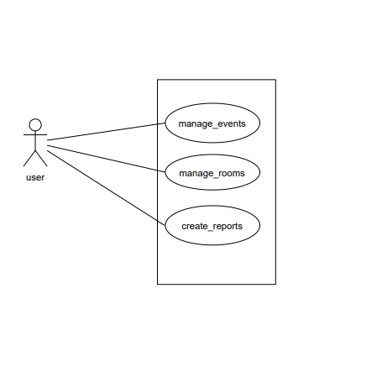

***Fig 2.2.1:*** *Use case diagram*

2.2.2 Non Functional Requirements

Non-functional requirements are those type of requirements which is not directly concerned with the system functionality but in absence of it reduces the quality of the system process. Some of non-functional requirements of the system is as follows;

* The system should be able to handle the process fast.
* The users should provide all the information of events.

## 2.3 Feasibility Analysis

Feasibility analysis is a part of system analysis carried to confirm that the system being developed is actually feasible or not. This is the phase where any system designers are able to know whether to start the project or not.

We performed some study and analyzed the system and get to know that it is feasible to make the system. Mainly four types of feasibility studies were done. They are; Economic, Operational, Technical and Scheduled feasibility.

2.3.1 Technical Feasibility

This is a web-based application. It uses Python as a back end, Postgresql and XML to store and manipulate data. It is based on client server architecture and needs internet connection to access the information. All the technology required by the application and can be accessed freely, hence it is technically feasible.

2.3.2 Operational Feasibility

The end users are the client of the application. They are the one who manages the events of an organization. The server keeps the records of various information of events and users. The application can be accessed from anywhere with an internet connection and authentication. It is easy to use. Thus, this project is operationally feasible.

2.3.3 Economic Feasibility

Developing and deploying the system will be economic. For development, PC’s that support any operating system with some application is sufficient. For deployment, a PC with internet is required. During the data collection too, not much cost was spent and same with time as well. Further, it does not cost too much to develop and access this system. And hence, we can say that this system was economically feasible.

2.3.4 Schedule Feasibility

A system is said to be scheduled feasible if it is implemented within the planned scheduled.

This project is being developed for the in-house use and doesnot have a tight schedule. So, this project is expected to be completed on time.

## 2.4 Structuring System Requirements

Giving structure to system requirements helps to get better idea about the system process and to know how the system actually works. Different models can be designed to represent the system and show the flow of data in different part of the system. In this project, various activities regarding the relationships, data manipulations and data processing were carried out. Relationships between two or more entity sets were created, so that they can provide better information while searching result in the system. The data processing is represented in the diagrammatic form so that every individual who look at the diagram can understand about the main gist of the system. Diagrams are made following the Structured Approach that contains ER-Diagram (Entity Relationship Diagram) as a data modeling approach.

2.4.1 Data Modeling

The ER-Diagram contains different entity sets, relationship sets along with their properties and data flow direction. By defining the entities, their attributes, and showing the relationships between them, an ER diagram illustrates the logical structure of databases. The system contains the following entity sets;

**USERS**

They are the persons who uses system. They can manage events, rooms and create reports.

**EVENTS**

These are the events that occurs within the organization.

**EVENT_TYPES**

The event can be classified to many types such as Internal meeting, Group discussion.

**ROOMS**

These are the rooms that can be used to carry out the events.

**AGENDAS**

Agenda are the actual outcomes of the events.

The following figure shows the Entity Relationship Diagram of the system;

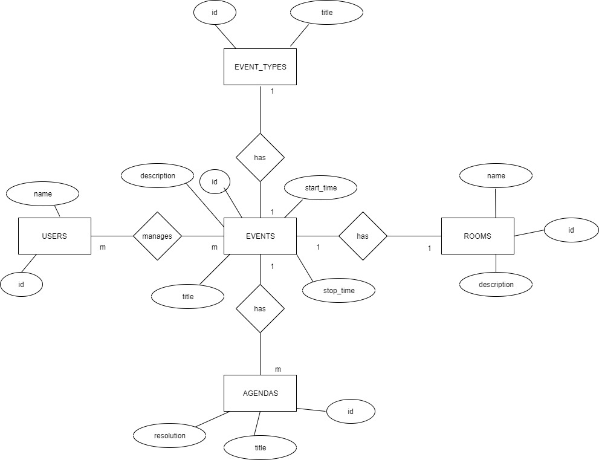

***Fig 2.4.1:*** *ER-Diagram of the system*

# CHAPTER 3

# SYSTEM DESIGN

## 3.1 Block Diagram

As the system is a part of large system, the user is created by the superuser of the system. Thus created user are the end users of the system and are responsible for the management of the events that occurs within the organization. The user can create rooms, create events and generate the reports after the events are carried out.

The block diagram of the system is as follows;

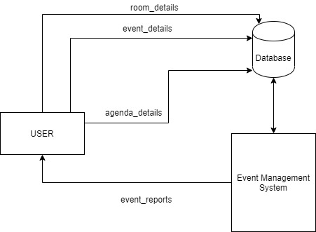

***Fig 3.1:*** *Block Diagram of the system*

## 3.2 Database Schema Design

Database schema design is the overall representation of database tables in a way that represents all the relation between them. The database schema design is given below;

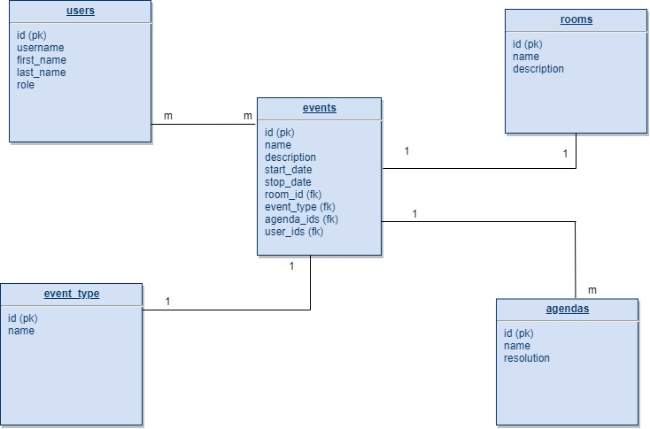

***Fig 3.2:*** *Database Schema Design*

## 3.3 Process Design

Process Design is a part, where different processes in the system are connected with the sources and sink so that the actual flow of data in the system is displayed to the report header. Data flow diagram helps to represent the flow of data in the system. Context diagram and level 1 DFD are created in order to show the overall process in the system.

3.3.1 Data Flow Diagram

A data-flow diagram (DFD) represents a flow of our data of a process or a system. The DFD also provides information about the outputs and inputs of each entity and the process itself. A data-flow diagram has no control flow, there are no decision rules and no loops. Basically, DFD explains how data is processed in terms of input and output.

**Context Diagram**

Context Diagram or Level 0 DFD explains the first level of data flows in the system. In this system user is the main entity. As we can see in the following figure, there is an event management system where the data is inherited from user. The user provides the data in the form of room_details, event_details and agenda_details and the system responses according to the input. The context diagram is as follows;

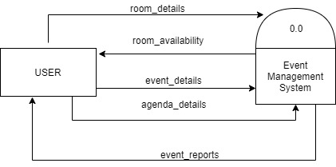

***Fig 2.4.2.1 (1):*** *Context Diagram*

**Level 1 DFD**

The decomposed process is now further decomposed into other sub processes and is called as level 1. Level 1 is more in-depth version of level 0 DFD. In level 1 DFD the system is further divided into two system; one checks the availability of rooms and another creates events and reports. The level 1 DFD is shown in figure below;

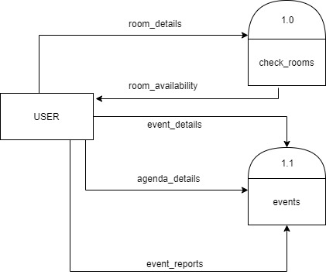

***Fig 2.4.2.1 (2):*** *Level 1 DFD*

# CHAPTER 4

# SYSTEM IMPLEMENTATION

## 4.1 Implementation Tools

This is the phase where the actual system is build. Firstly, the whole information gathered are studied, analyzed and then it was processed to build an actual system. The main tools used to develop the system are as follows;

4.1.1 Odoo Framework

Odoo is a popular ERP framework that provides different kinds of features related to enterprise in the form of application and modules. Odoo is a python framework and is very useful due to its large number of application and modules. Due to its strong design structure and richness of application and modules, it is easier to design and develop the requirements.

4.1.2 XML

XML is used as both frontend and backend tool for this system. It is used to create the user interface which works similar to HTML. Furthermore, XML is also used in backend to store the data into database as a record.

4.1.3 Python

All the backend code is done by using python. As python is high level language, its easier to implement the business logic with minimum effort. Due to its richness in libraries python makes easier to develop any type of system in much less time.

4.1.4 PostgreSQL

PostgreSQL is an open source relational database management system and can handle a wide range of workloads. Due to the size of application, PostgreSQL is a mandatory database in odoo framework.

4.1.4 GIT

Git is a free and open source distributed version control system designed to handle everything from small to very large projects with speed and efficiency.

## 4.2 Development Methodology

As the system does not have any fixed requirements and is being developed for the in-house use, agile method is used. In the agile methodology after every development iteration, the user is able to see the result and understand if he is satisfied with it or he is not. This is one of the advantages of the agile software development life cycle model. One of its disadvantages is that with the absence of defined requirements it is difficult to estimate the resources and development cost. Extreme programming is one of the practical uses of the agile model.

# CHAPTER 5

# SYSTEM TESTING

## 5.1 Unit Testing

Particular units of programs were tested at a particular time instance to determine if the block of codes is working properly. Besides, the flow of data and values within the system is checked too.

***Table 5.1 (1):*** *Test cases for room creation*

|  |  |  |
| --- | --- | --- |
| **S.N.** | **Input** | **Output** |
| 1. | **Name:** “blank”  Description: This room is for internal meeting. | Room name cannot be blank. |
| 2. | **Name:** Room A  **Description:** This room is for internal meeting. | Room Created. |

***Table 5.1 (2):*** *Test cases for event creation*

|  |  |  |
| --- | --- | --- |
| **S.N.** | **Input** | **Output** |
| 1. | **Title:** Odoo Discussion  **Event Type:** Group Discussion.  **Start Date:** 2019-12-17-12-30  **Duration:** 02:00  **Description:** Odoo group Discussion  **Room:** Room B | Event Created Successfully. |
| 2. | **Title:** GIT discussion  **Event Type:** Group Discussion.  **Start Date:** 2019-12-17-12-30  **Duration:** 01:00  **Description:** Odoo group Discussion  **Room:** Room B | Error: Room B is reserved for event Odoo Discussion. |

***Table 5.1 (3):*** *Test cases for report generation*

|  |  |  |
| --- | --- | --- |
| **S.N.** | **Input** | **Output** |
| 1. | Selected an event and pressed print button. | Event report created and downloaded. |
| 2. | Selected multiple event and pressed print button. | Multiple event report created and downloaded in single file. |

## 5.2 User Interface Tesing

The designed user interface was tested with different browsers (Internet Explorer, Firefox, Google Chrome, etc.) to check whether the display of contents is consistent or not. The display of the content is found to be consistent in a different browser.

## 5.3 System Testing

System testing is conducted in a complete, integrated system to evaluate the system with its specified requirements. In this testing, whole application was tested to check for errors. The complete application was tested by implementing it in another version of odoo. As the system is working fine for different version it is ready for real world implementation.

# CHAPTER 6

# CONCLUSION

The project has been a successful platform to manage the events that occurs within an organizations. All the events can be managed without any real effort and difficulty. The resource planning process becomes easier with the help of this Event Management System On top of that this system helps to create the reports of any events that occurs within an organization.

ERP application have become extremely common in recent years and is applied in many organizations. So, in this system the event are managed with ease and can be recorded for future use. The system keep track of all the things that occurs within organization and makes the event manage and planning a lot less time consuming.

Furthermore, during this internship, I have learnt many things about writing codes, using framework and different packages, designing database and managing project. In this report, I have tried to include overall findings of internship and knowledge that I have gained during my internship. This period has really been fruitful, as I have chance to work on different projects under the supervision of seniors. I had learned various new technologies and understand how the software development activities are being conducted in the real field and market.

My major focus was developing application in python, which I got chance to implement by developing the modules in odoo framework. During this period I got to work on different application which helped to sharpen my programming skills and it also helped me to learn new technologies like GIT and Docker.

The team of Vacker360 have always helped me to sharpen my knowledge and to acquire new skills in the web development.

# BIBLIOGRAPHY

* Odoo 12 Official Documentaion: <https://www.odoo.com/documentation/12.0/>
* Odoo 12 Development Essentials Textbook
* PostgreSQL official Documentaion: <https://www.postgresql.org/docs/>
* XML Tutorials: <https://www.tutorialspoint.com/xml/xml_overview.htm>